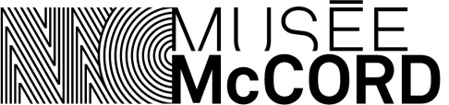

Consent Form

The McCord Museum would like to use pictures of visitors. To do so, we need your permission. The Museum thanks you for your kind cooperation.

1. Subject
Hereby, I authorize the photographer(s) of the McCord Museum to take the picture of my child.

2. Operations
By this, I agree that the McCord Museum take the picture of my child. I also authorize irrevocably the McCord Museum to use, distribute or otherwise utilize, and without time or territorial limits, pictures or parts of pictures of myself and/or my child(ren) taken during the photo shoot, and all other components of the pictures related to my participation.

3. Means of diffusion
This authorization includes, but not limited to, the right to reproduce, represent and communicate the material to the public, in whole or in part, or any medium and by any mode of transmission now known or invented, including telecommunications, interactive Web-based or otherwise.

4. Compensation
It is agreed that I will not take advantage of any remuneration or compensation of any kind or commission or privilege.

Read and approved in Montreal, on ________________________________________________________

Signature: ____________________________________________________________________________

Name: _______________________________________________________________________________

Name of child: _________________________________________________________________________

Address: ______________________________________________________________________________

Zip code: ______________________ Phone number:_________________________________________
E-mail: _______________________________________________________________________________

